|  |
| --- |
| Migrate your GoDaddy domain to Route53Process-1: Migrate Nameservers to route53Step 1:open Route53, **create a hosted zone**.https://miro.medium.com/v2/resize:fit:1050/1*OZ1Gal9wNO8-lc8Tc5bOuA.pngStep 2:Click the **Create Hosted Zone** |
| Go to DNS managementSelect your domainEdit the nameservers and add the ns which you have created in the aws route53 |

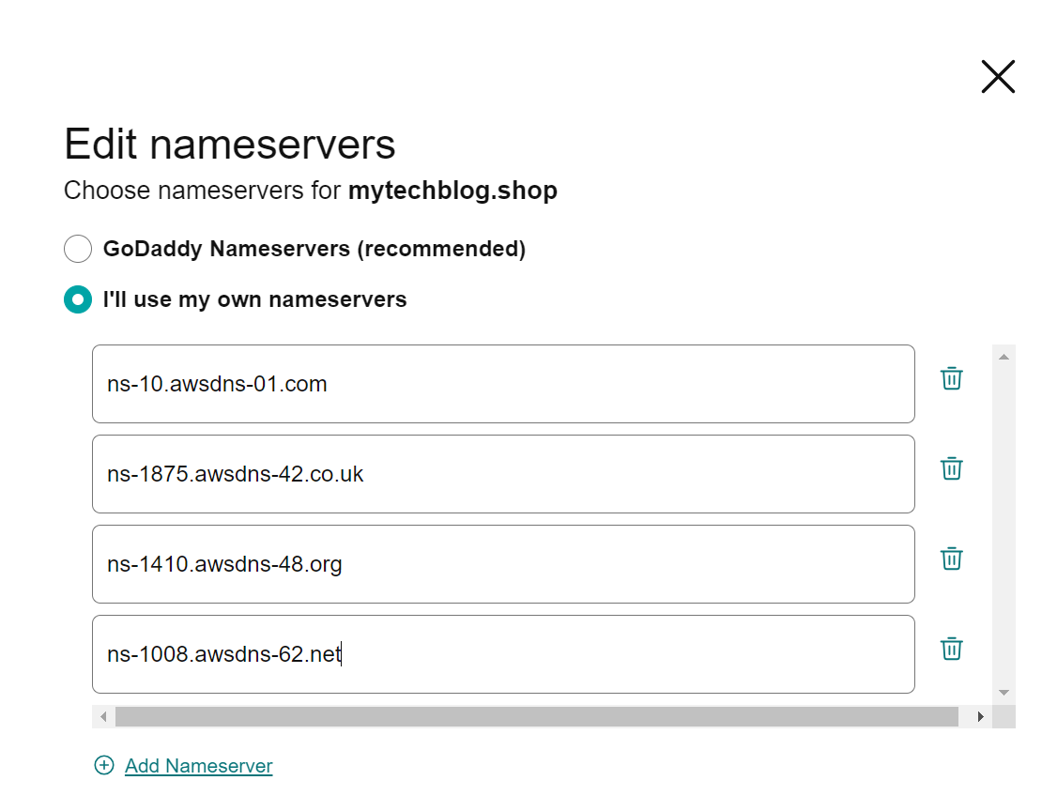

* Click on continue

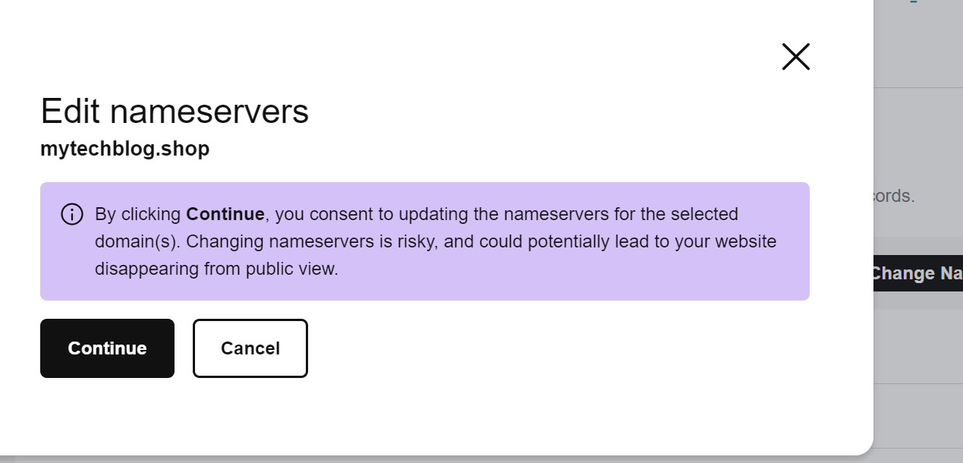

* The Nameservers are added to GoDaddy domain.

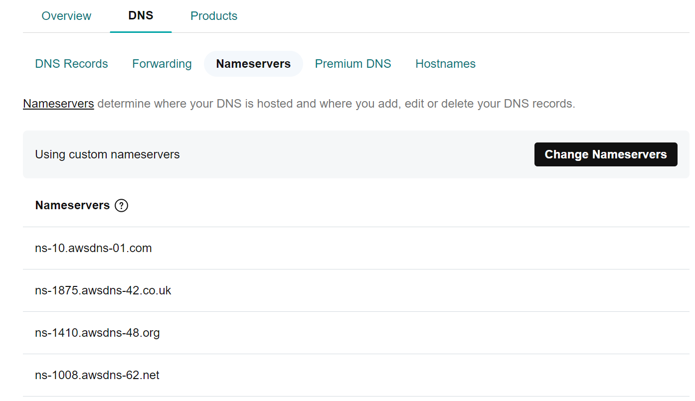

* But it may take up to 24 hours to propagate your new nameservers, but from my experience, it’s **usually around 15 minutes**.
* To check whether the nameservers are added to the domain or not <https://www.nslookup.io/domains/mytechblog.shop/dns-records/ns/>

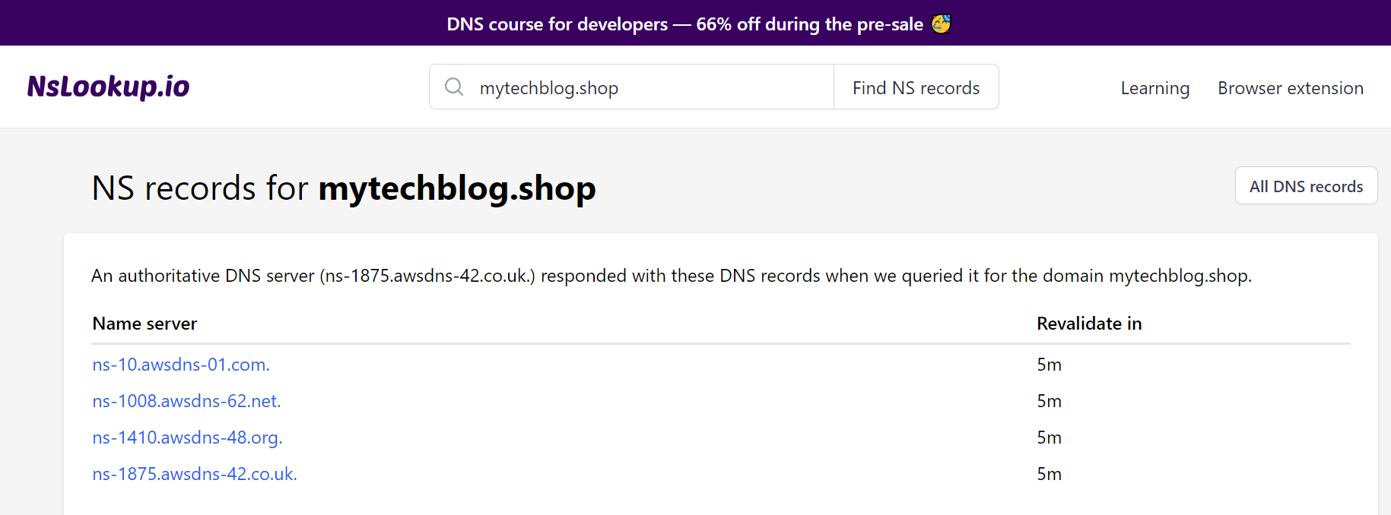

# Connect your Route53 domain to an EC2 instance where my application is running

* Create a ‘A’ type record

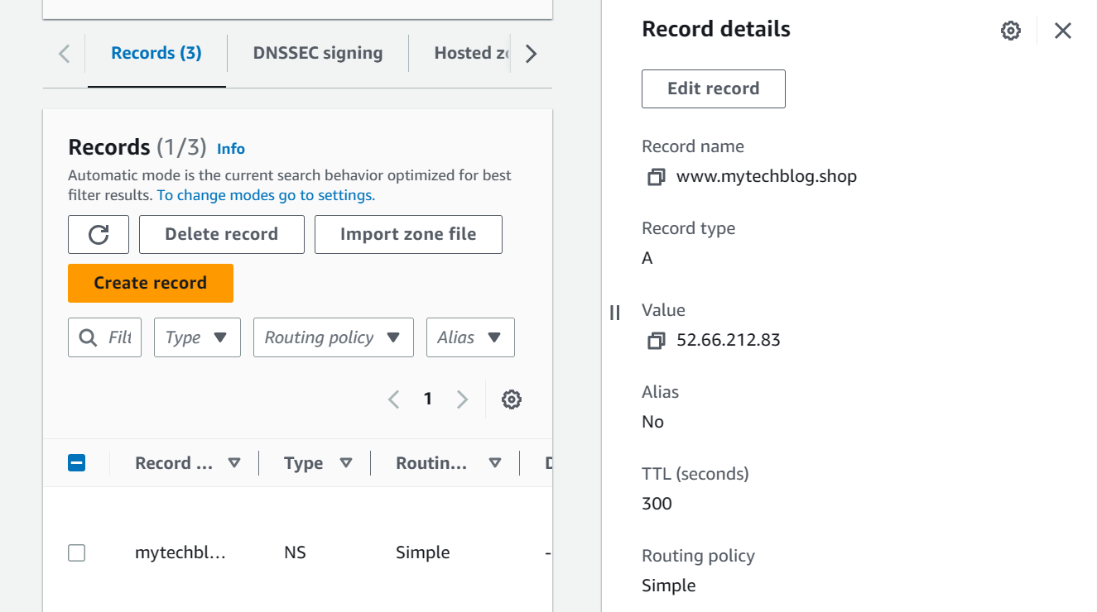

* After our nameservers are added to the domain, we can browse the application using the domain name

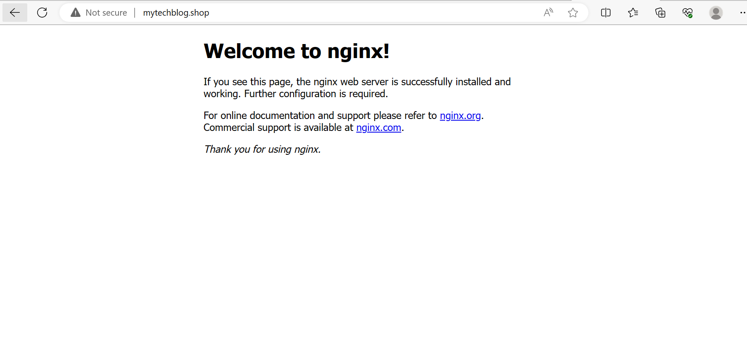

### Rollback:

* **Step 1:** Prepare for Rollback:
* Before proceeding with the migration, take note of your current nameservers and DNS settings in GoDaddy. You will need this information to rollback in case of any issues during the migration.
* **Step 2:** Testing and Rollback:
* Once the migration has had time to propagate, test your website and services to ensure they are working correctly with the new DNS settings.
* If any issues arise, you can roll back to the previous DNS settings in GoDaddy:
* Log in to GoDaddy and revert the nameservers back to the original ones (the ones you noted down before the migration).

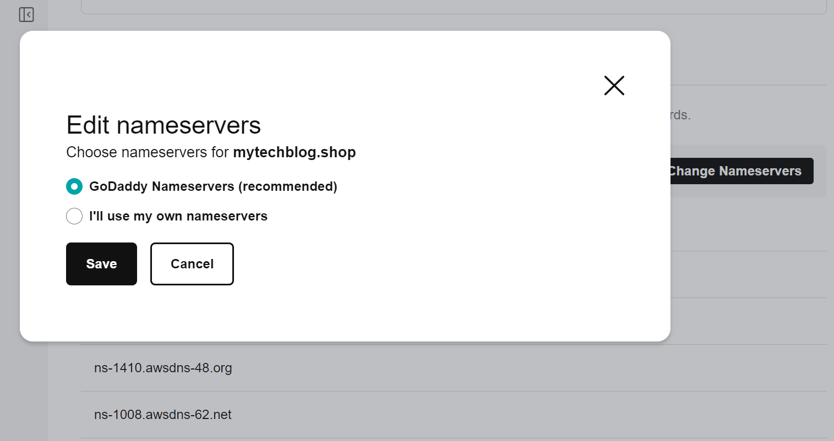

* DNS propagation might take some time again.
* Investigate and resolve any issues before attempting the migration again.
* By following these steps and preparing for a rollback, you can ensure a smooth migration of your domain's nameservers from GoDaddy to AWS Route 53 while having the safety net to revert to the original settings in case of any problems.

### Process-2: Domain transfer

* To transfer a domain from GoDaddy to Amazon Route 53, follow these steps:

**Step 1: Prepare for Domain Transfer:**

* Unlock your domain in GoDaddy to allow for transfer.
* Disable the domain privacy protection (if enabled) as it can interfere with the transfer process.

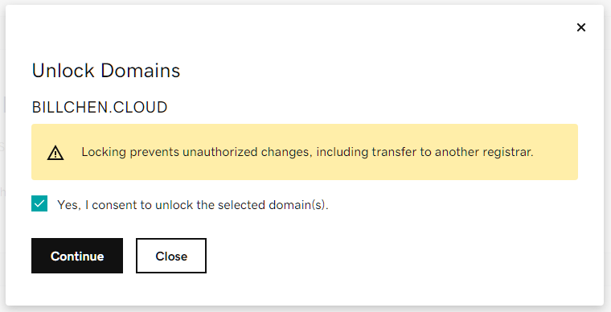

* Obtain the domain's authorization code (also known as EPP code) from GoDaddy. This code is needed for the transfer process and serves as an additional security measure.

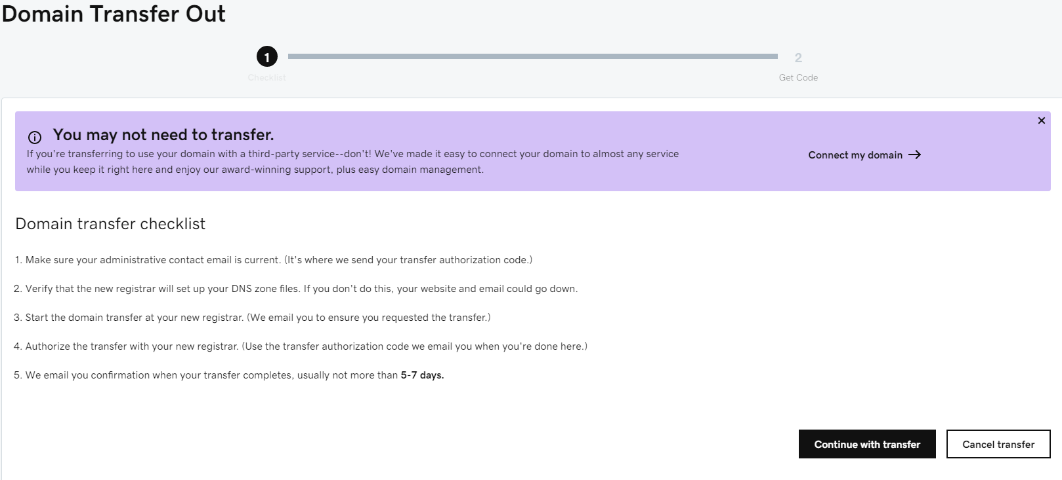

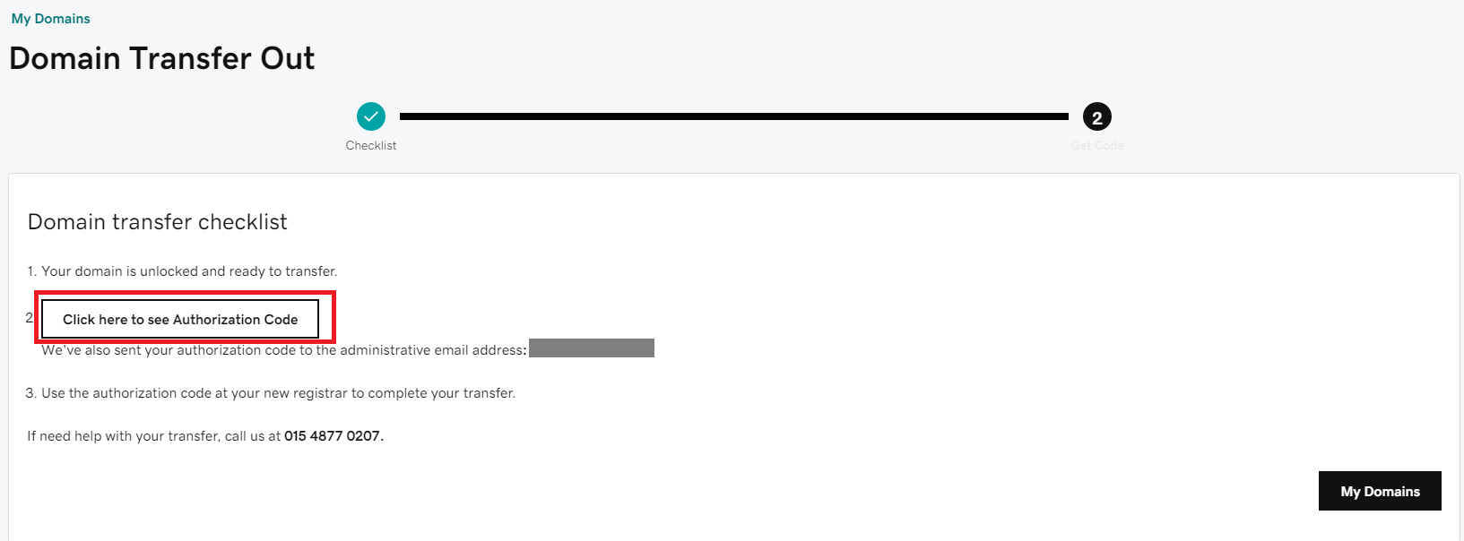

**Step 2: Create a Hosted Zone in Route 53:**

* Go to the AWS Route 53 console: https://console.aws.amazon.com/route53/
* Create a new hosted zone for the domain you want to transfer. Note down the assigned nameservers provided by Route 53 for the hosted zone.

**Step 3: Initiate Domain Transfer in Route 53:**

* In the Route 53 console, click on "Registered domains" in the left sidebar.
* Click the "Transfer domain" button.

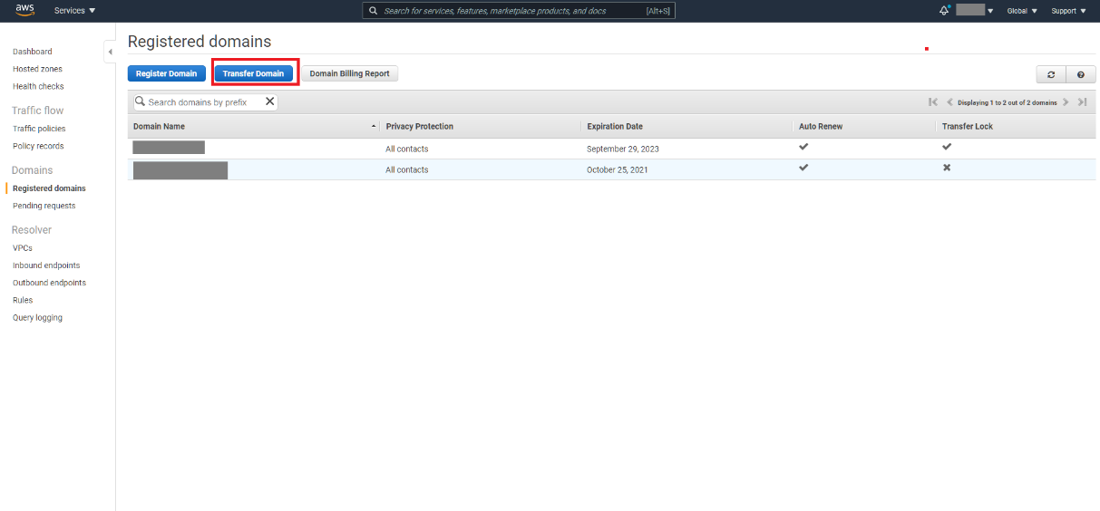

* Enter the domain name you want to transfer from GoDaddy to Route 53.
* Follow the on-screen instructions and provide the authorization code when prompted.

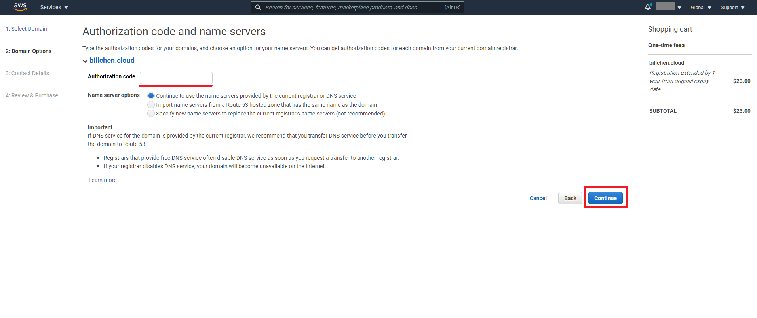

* Complete the payment for the domain transfer.

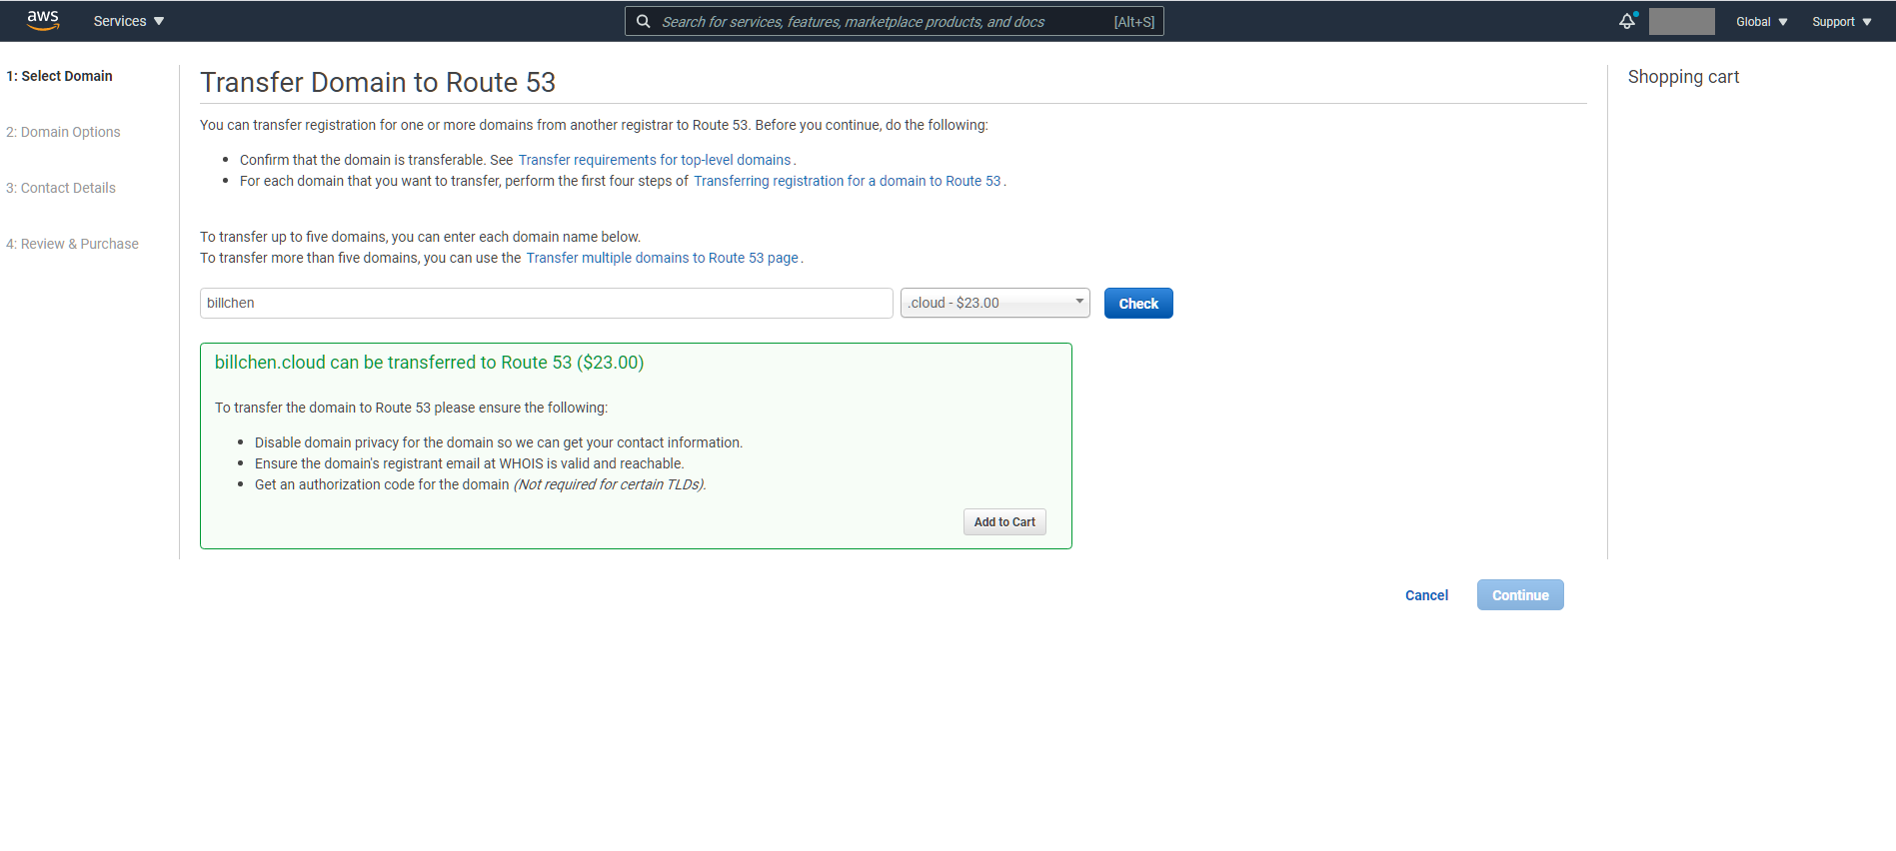

**Step 4: Confirm Transfer (Email Verification):**

* An email will be sent to the domain's administrative contact (the email address listed in the WHOIS database).
* The recipient of the email needs to confirm the domain transfer by following the provided instructions. This step is essential to authorize the transfer.

**Step 5: Wait for Domain Transfer:**

* The domain transfer process can take several days to complete. During this time, the domain will remain accessible from GoDaddy's nameservers.
* Once the transfer is successful, the domain will be managed within your Route 53 hosted zone.

**Step 6: Verify and Adjust DNS Settings:**

* After the transfer is complete, review the DNS settings in your Route 53 hosted zone to ensure they are correct.
* Make any necessary adjustments to point your domain to the desired resources (e.g., web servers, email servers) hosted on AWS or elsewhere.

**Step 7: Verify Domain Functionality:**

* Test your website and services to ensure they are working correctly with the new DNS settings in Route 53.
* Note: Be aware that domain transfers might involve a domain transfer fee, which will also extend the domain registration period. Ensure you have a valid payment method associated with your AWS account to cover the transfer cost.
* It's crucial to perform these steps carefully to avoid any downtime or disruptions during the domain transfer process.

